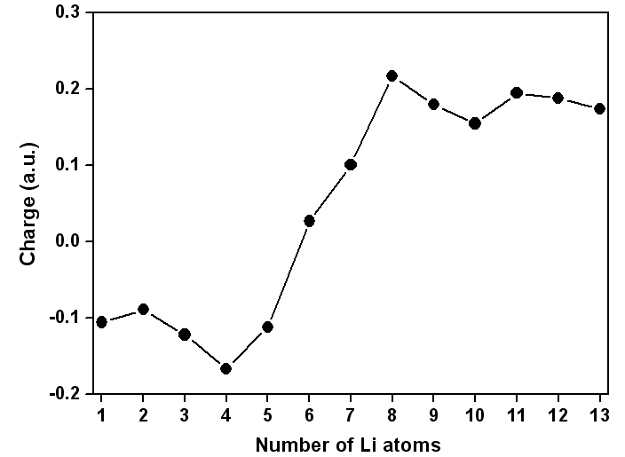
Figure 4. The atomic charge (a.u.) on V atom of the VLi_{n} clusters (n=1-13) for the lowest-energy structures.

